Django Installation : <https://drive.google.com/drive/folders/1WvaGaTY1COHs60n21Uopb35LHQZvhYzX?usp=drive_link>

MongoDB Installation: <https://docs.google.com/document/d/17Tnhoh14Uc0m0YbSsuCwhRelHUX_LrYT/edit>

After installation of django and the go to below website

<https://pymongo.readthedocs.io/en/stable/>

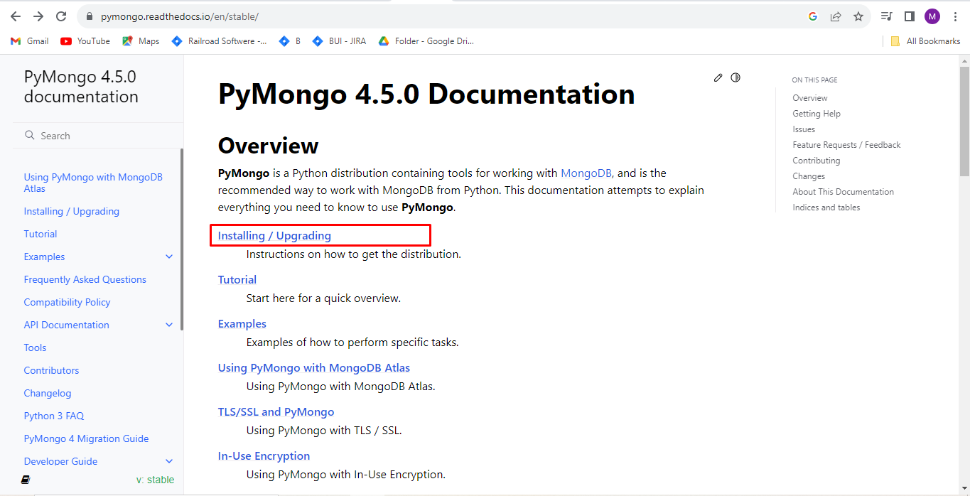

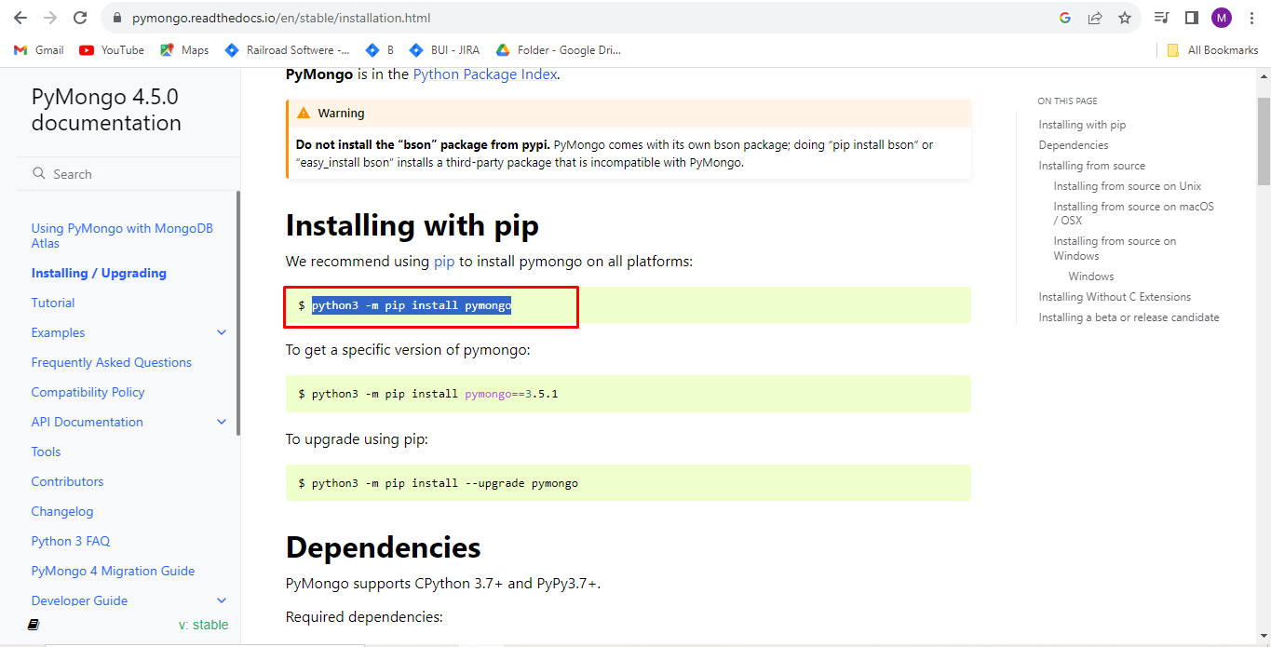

And then use this command to install pymongo package

**python -m pip install pymongo**

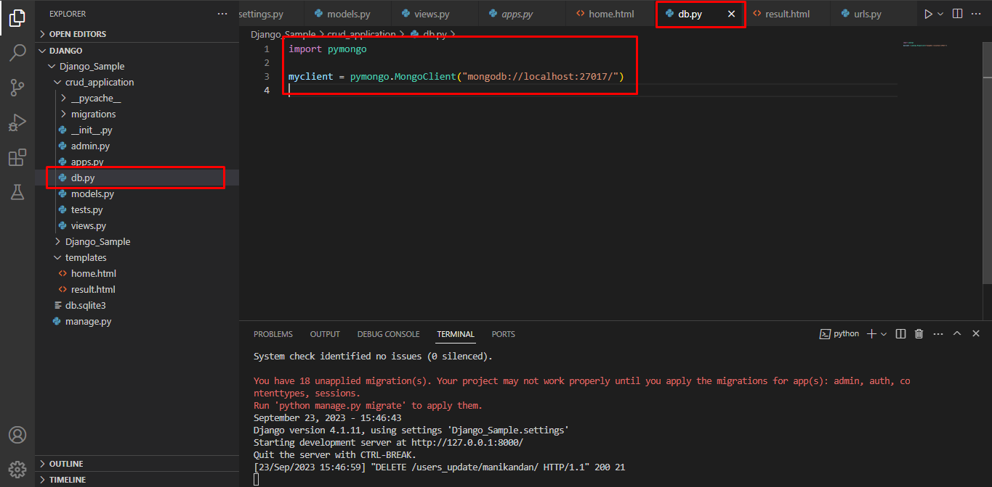

After go to our django application create db.py file and include above code

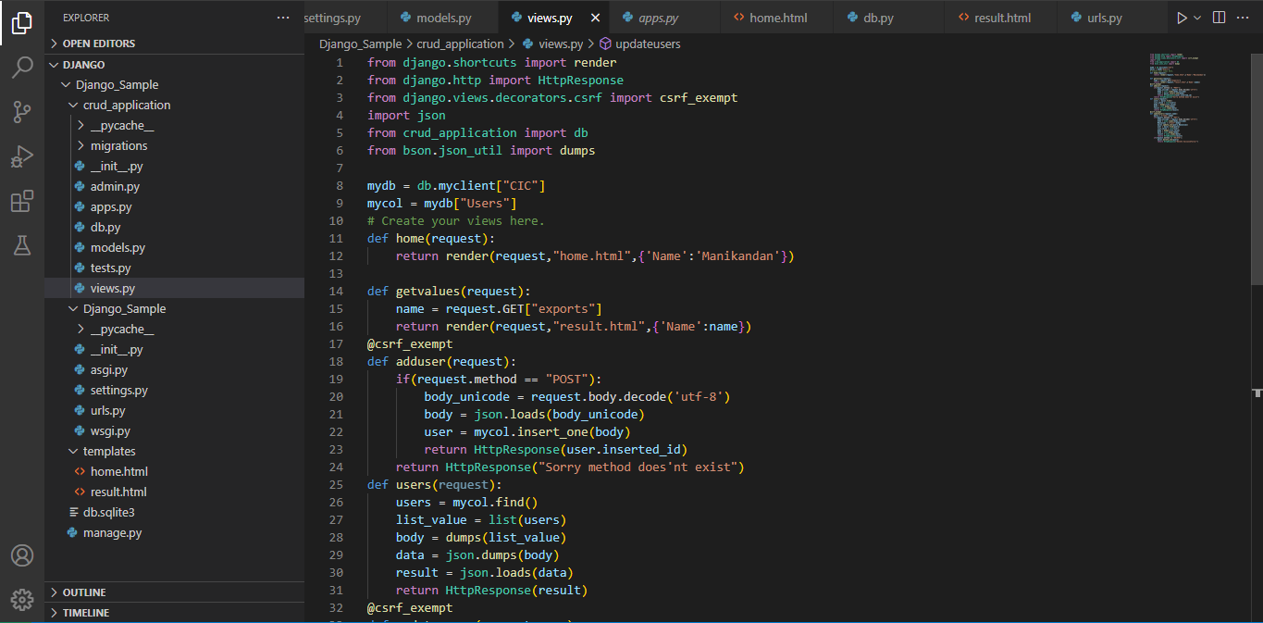

And the we can start crud operation

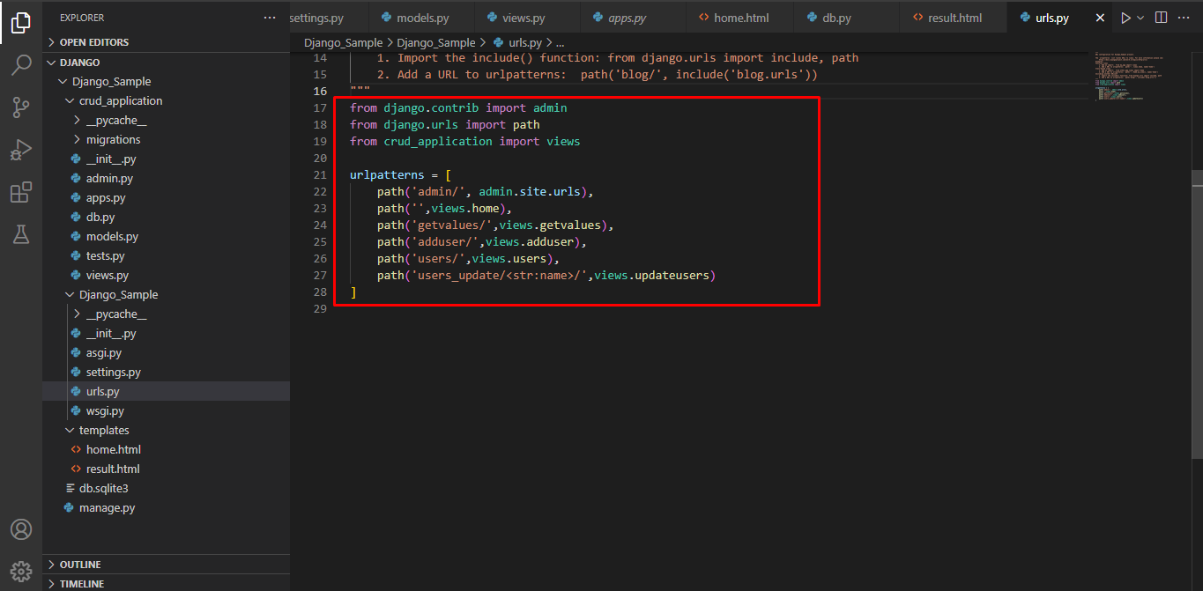

This is the route of functions

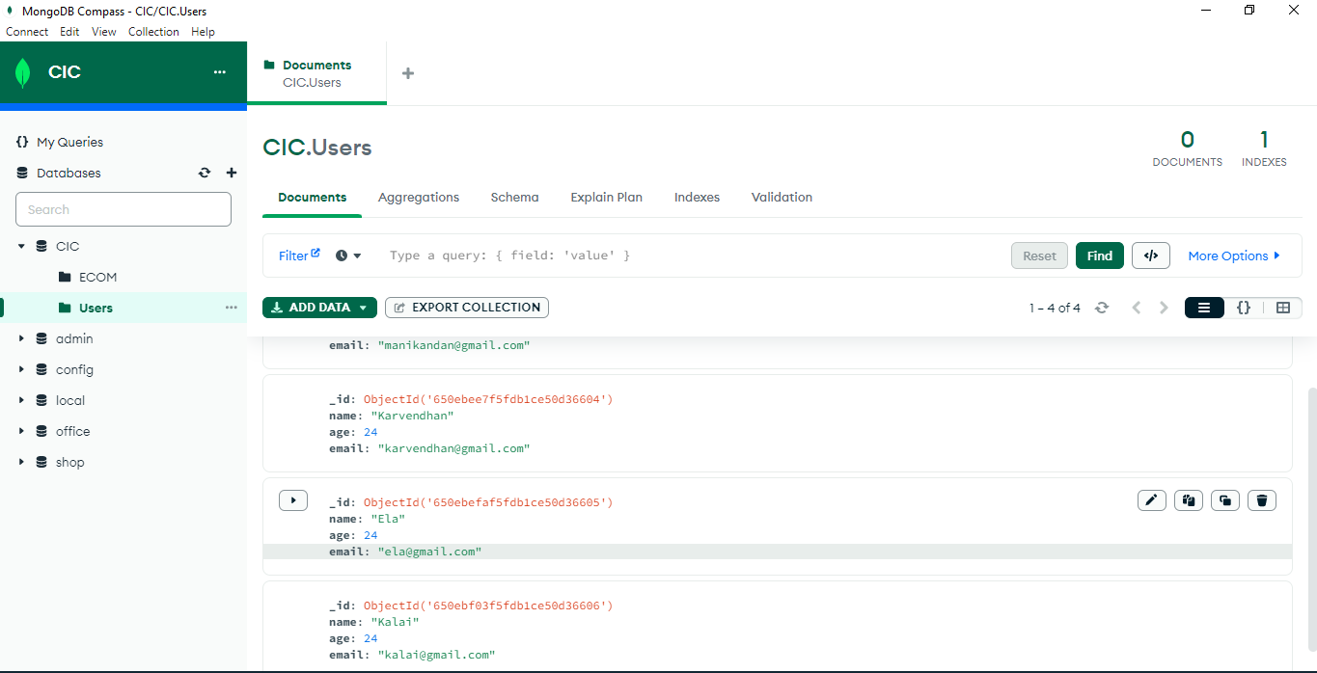

Crud Operations Results

SourceCode: <https://drive.google.com/file/d/1Vs77-P5wdvE3YGonlWcRKbQVOJkoBwvO/view?usp=drive_link>